**Objective :To design, deploy, and manage a containerized microservices architecture using AWS services, specifically AWS ECS Fargate or EKS (Elastic Kubernetes Service). The goal is to create a robust, scalable, and secure infrastructure to run microservices in the cloud using Docker containers**

Sevices used:

* **Amazon ECS Fargate** : AWS Fargate is a technology that you can use with Amazon ECS to run [containers](https://aws.amazon.com/containers/) without having to manage servers or clusters of Amazon EC2 instances. With AWS Fargate, you no longer have to provision, configure, or scale clusters of virtual machines to run containers. This removes the need to choose server types, decide when to scale your clusters, or optimize cluster packing. **Distribute incoming web traffic** to multiple targets like **EC2 instances, containers , Lambda functions**, etc. Handle modern web application needs: microservices, REST APIs, containerized apps.
* **AWS Application Load balancer** : The **Application Load Balancer** is a fully managed **Layer 7** load balancer provided by AWS as part of the **Elastic Load Balancing** family.
* **Docker** : Docker is a platform that allows developers to package applications and their dependencies into containers, which are lightweight, portable, and isolated units. Containers can run on any machine with Docker installed, making them ideal for cloud computing environments
* **Amazon ECR** : Amazon Elastic Container Registry (Amazon ECR) is an AWS managed container image registry service that is secure, scalable, and reliable. Amazon ECR supports private repositories with resource-based permissions using AWS IAM. This is so that specified users or Amazon EC2 instances can access your container repositories and images.
* **AWS Codepipeline** : CodePipeline is a continuous delivery service that automates the building, testing, and deployment of your software into production.
* **Our first step is to create a microservice and dockerizing it.**
* Before automating the entire process we can Build Docker images and test them locally to ensure correct functionality.
* For the dockerizing process we created a EC2 connected to it via SSH connection.
* **Commands for installing docker**

# Update packages

* sudo apt update -y

# Install Docker

* sudo apt install docker.io -y

# Enable and start Docker

* sudo systemctl enable docker
* sudo systemctl start docker

# Add ubuntu user to docker group

* sudo usermod -aG docker ubuntu

# Log out and log back in, then verify

* docker version
* Next step is the creation of Amazon ECR. We have cretated a private repository named ‘course-service’

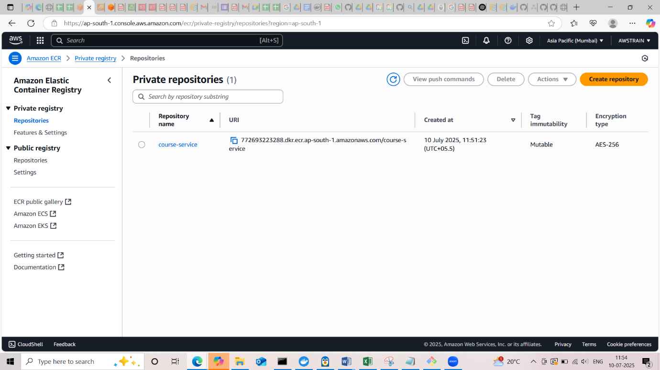

* Now we need to create Docker image. For that we have the Dockerfile in the root of our repository.

# Build Dockerimage

* docker build -t course-service:latest .

# Tag docker image for ECR

* docker tag course-service:latest <aws_account_id>.dkr.ecr.<region>.amazonaws.com/course-service:latest

# Login into ECR

* aws ecr get-login-password --region <region> | docker login --username AWS --password-stdin <aws_account_id>.dkr.ecr.<region>.amazonaws.com

# Push the image

* docker push <aws_account_id>.dkr.ecr.<region>.amazonaws.com/course-service:latest

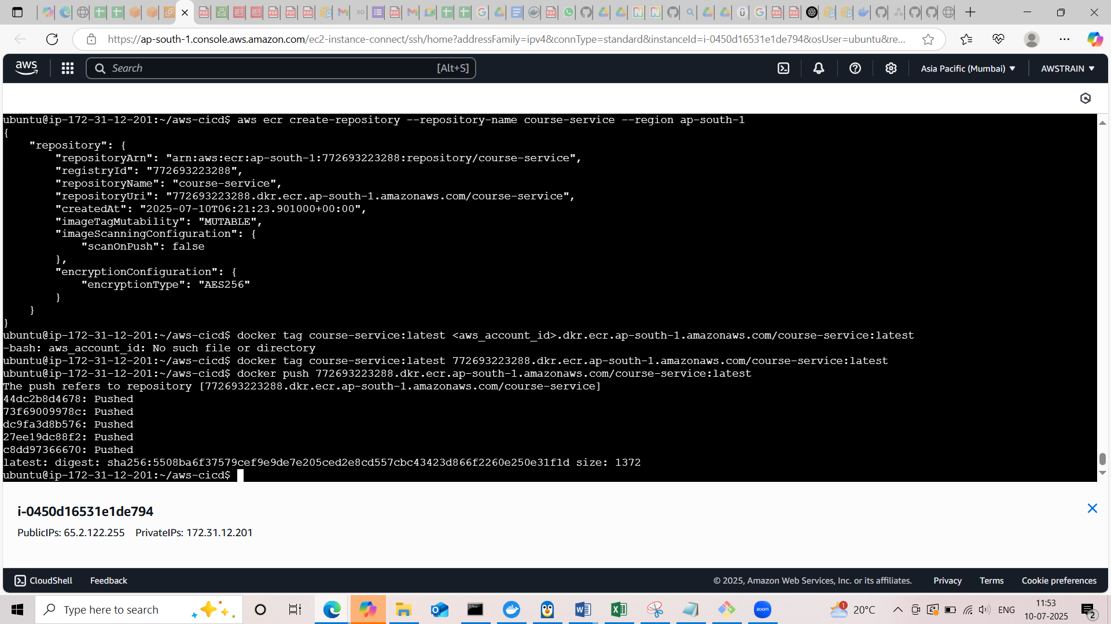

Now that we have successfully pushed the image to ECR

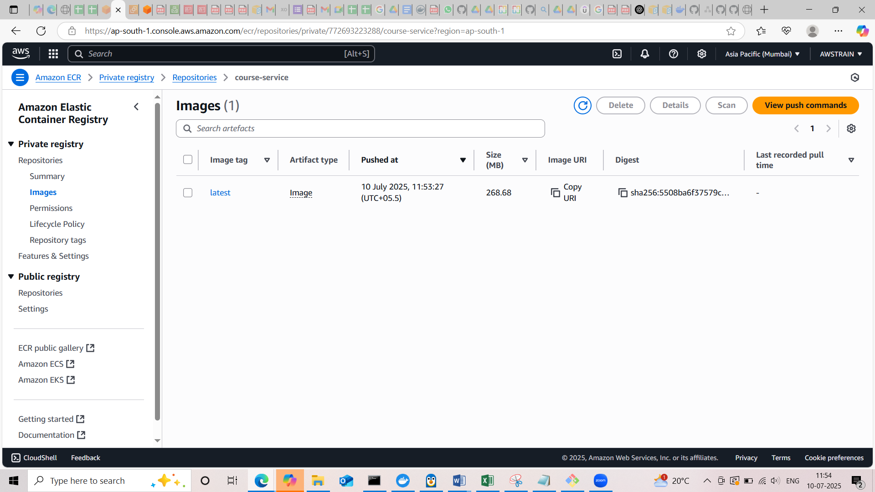

Here we verified the correct functionality by creating dockerimage and testing it locally and pushed to ECR!

* Now we have to automate the previous step of creating dockerfile and pushing to the ECR.For that we have buildspec.yml file in the root of our repository

**What is in builspec.yml**

| **Phase** | **Purpose** |
| --- | --- |
| install | Installs required runtimes (Java, Docker) inside the CodeBuild container. |
| pre_build | Logs in to Amazon ECR using AWS CLI. |
| build | Builds your application JAR and Docker image, then tags it. |
| post_build | Pushes Docker image to ECR, writes imagedefinitions.json for ECS/CodeDeploy. |

* Our next step is to create ECS cluster named ‘course-service-cluster’ with infrastructure AWS Fargate

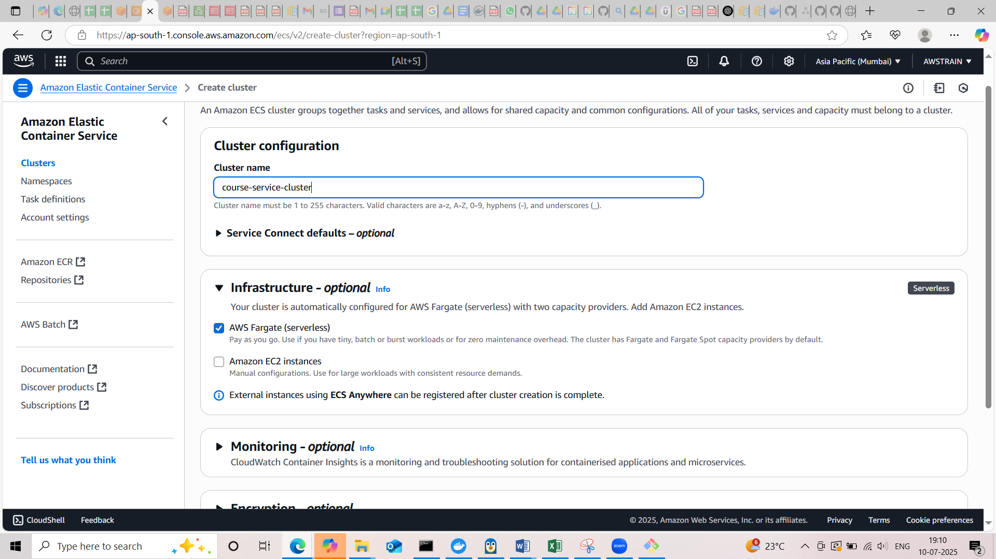

* Next we have to create task definition named ‘course-service-task ’
* Launch type is AWS Fargate
* Task execution role is ‘ecsTaskExecutionRole’
* Container name is ‘course-service’
* Provide the image URI in the container details
* Container port is 8080

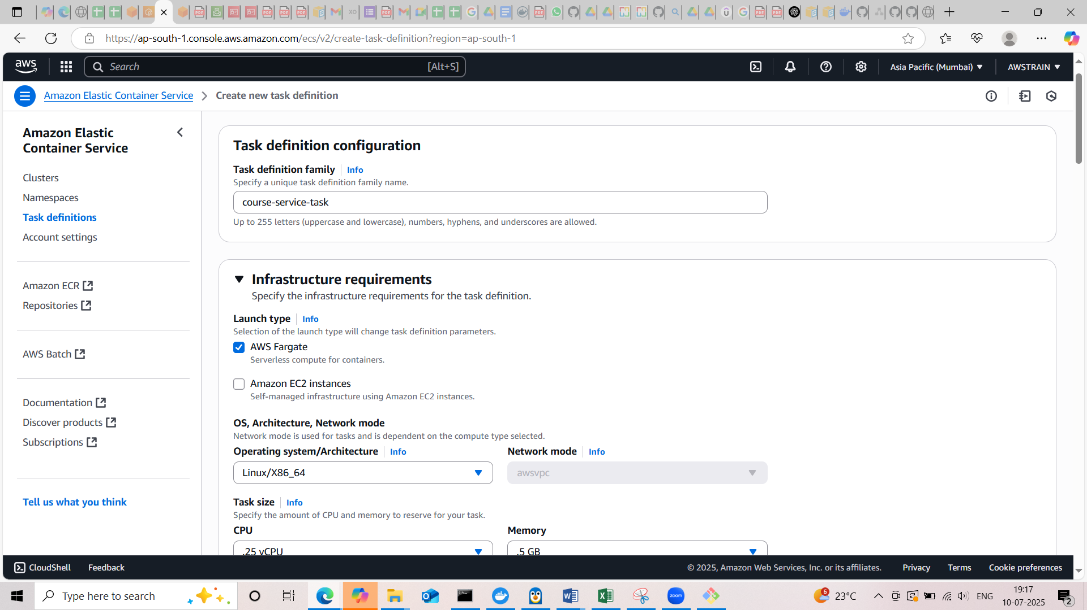

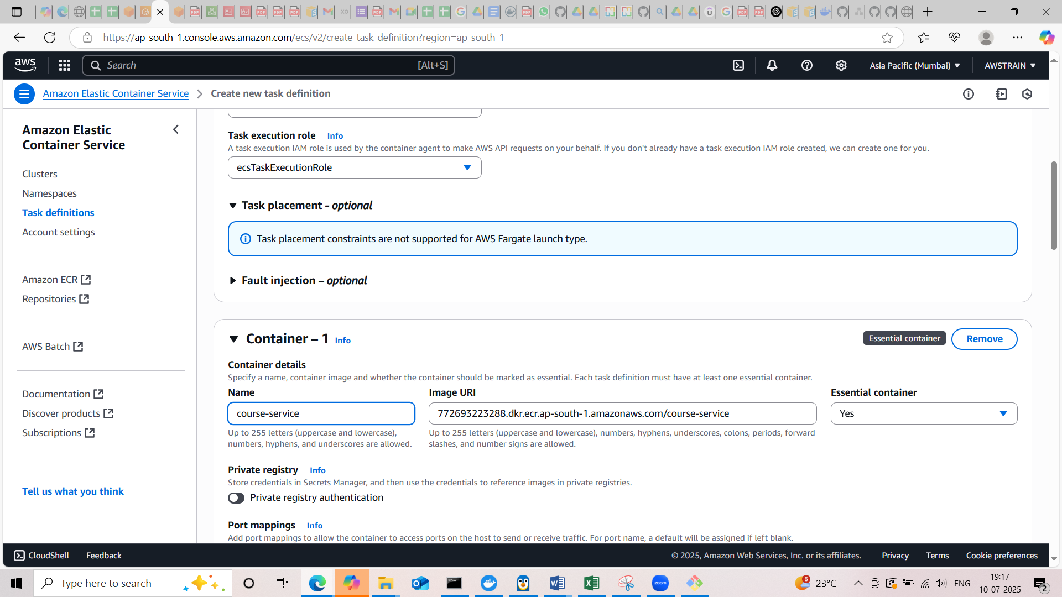

* ecsTaskExecutionRole contains ‘AmazonECSTaskExecutionRolePolicy’ and a policy for enabling cloudwatch logs

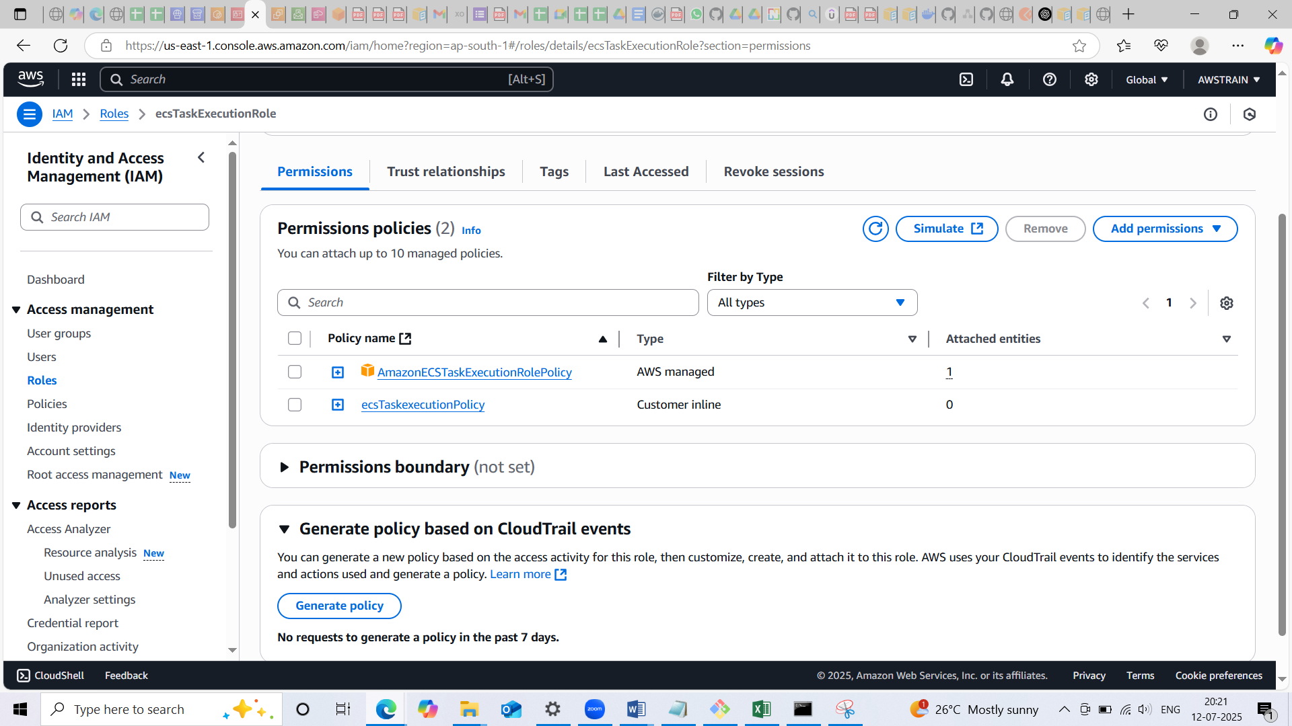

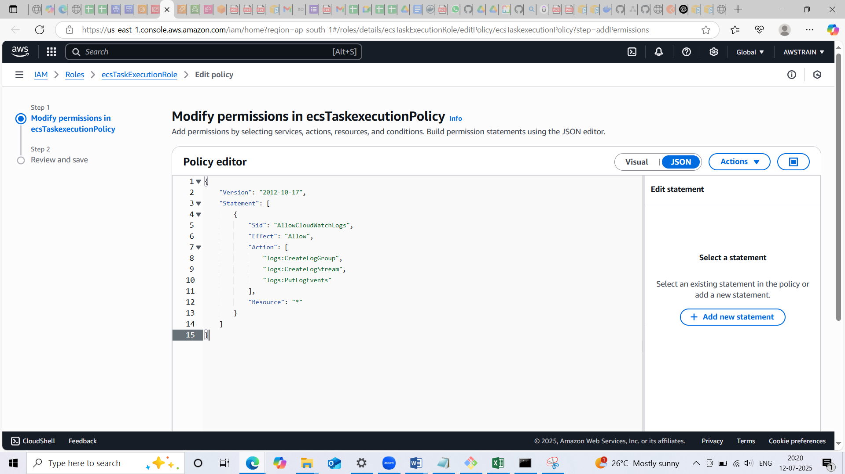

Hence created the task definition!

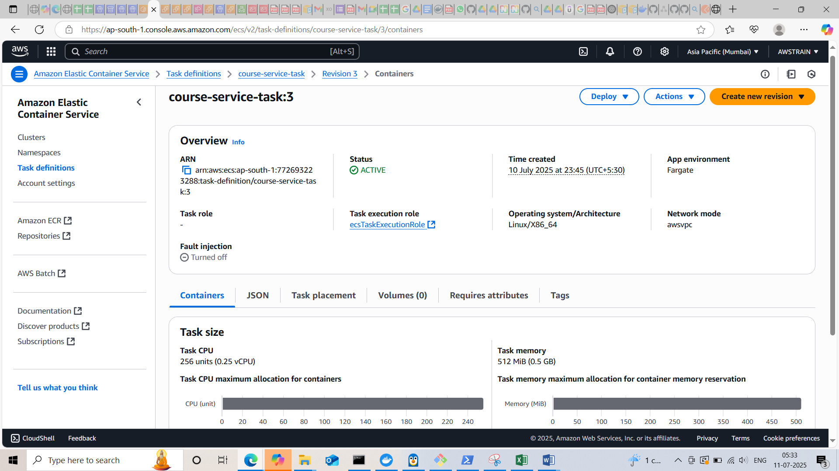

* We have to updated the task definition and container details in the appspec.yml file in the root repository

Our next step is to create the service. Before that we need to create a load balancer and two target group with one of them associated with the load balancer

* Created target group named ‘couse-blue’ and ‘couse-green’
* Target type is IP
* Port is 8080 (we are exposing port 8080 in dockerfile)

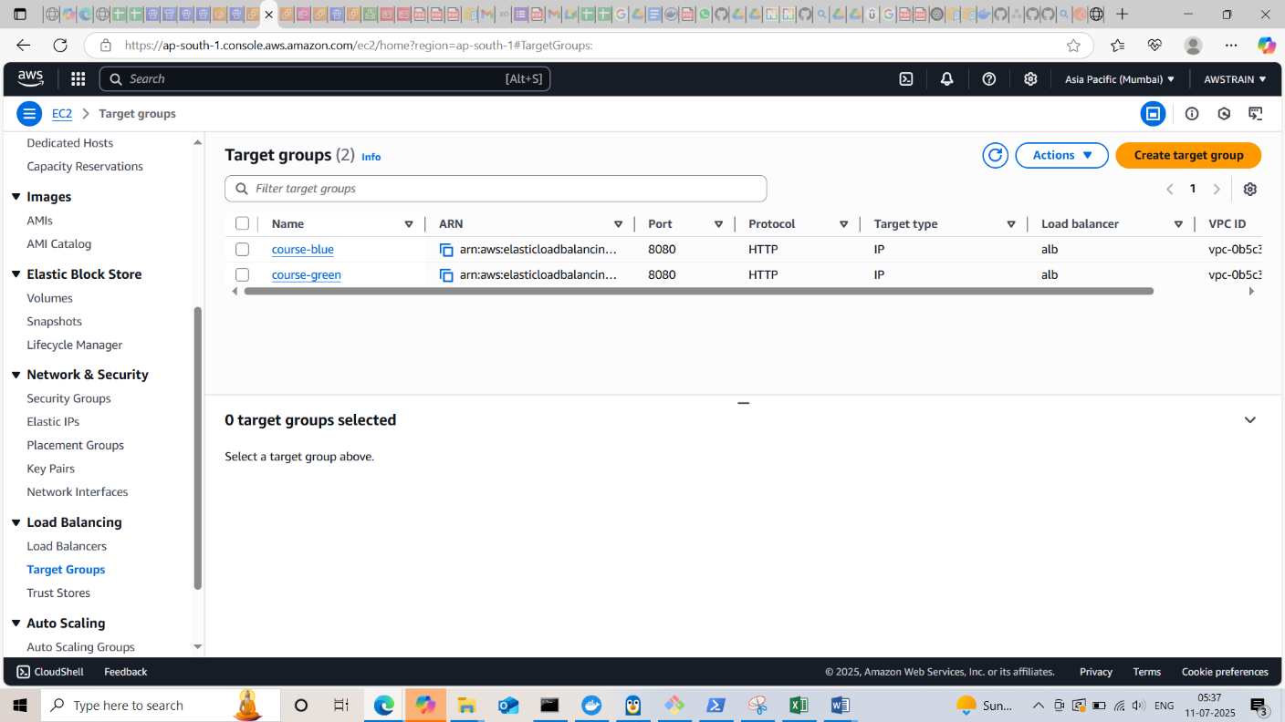

* In the next step, we created application load balancer named ‘alb’
* Add listener with HTTP:80 and forward it to the course target group.

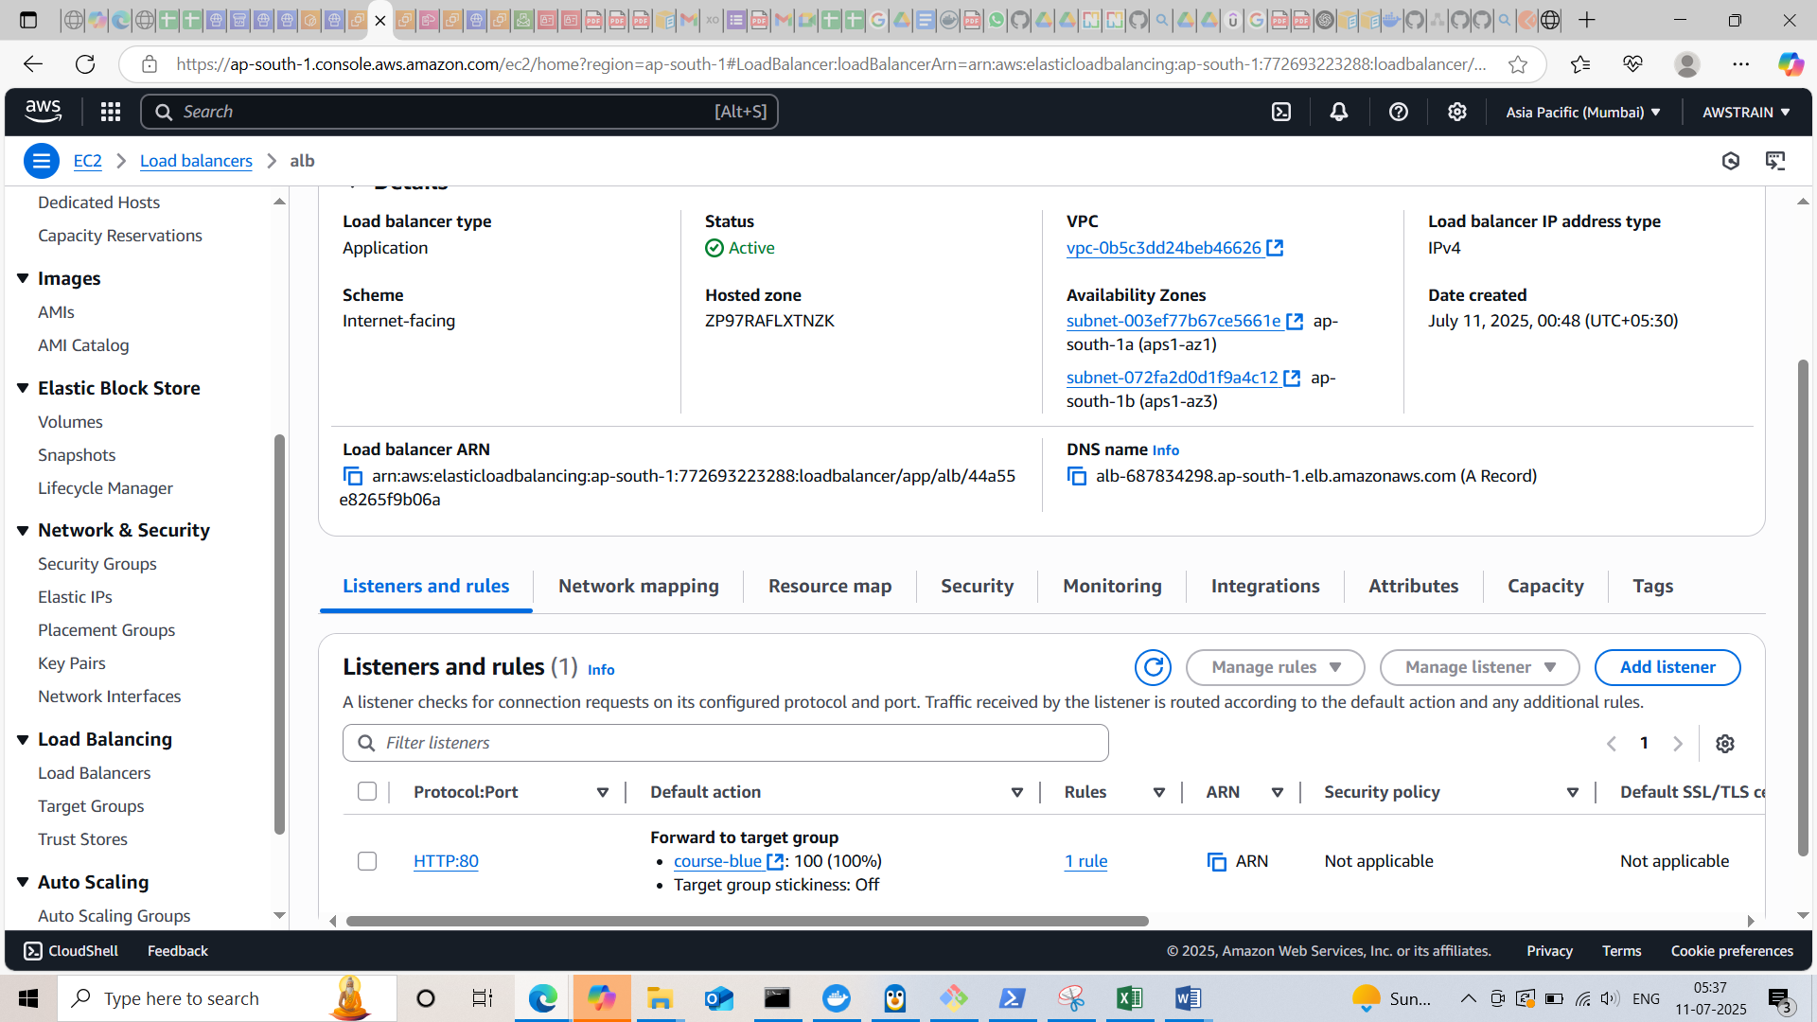

* Security group attached with the load balancer have the port 8080 exposed

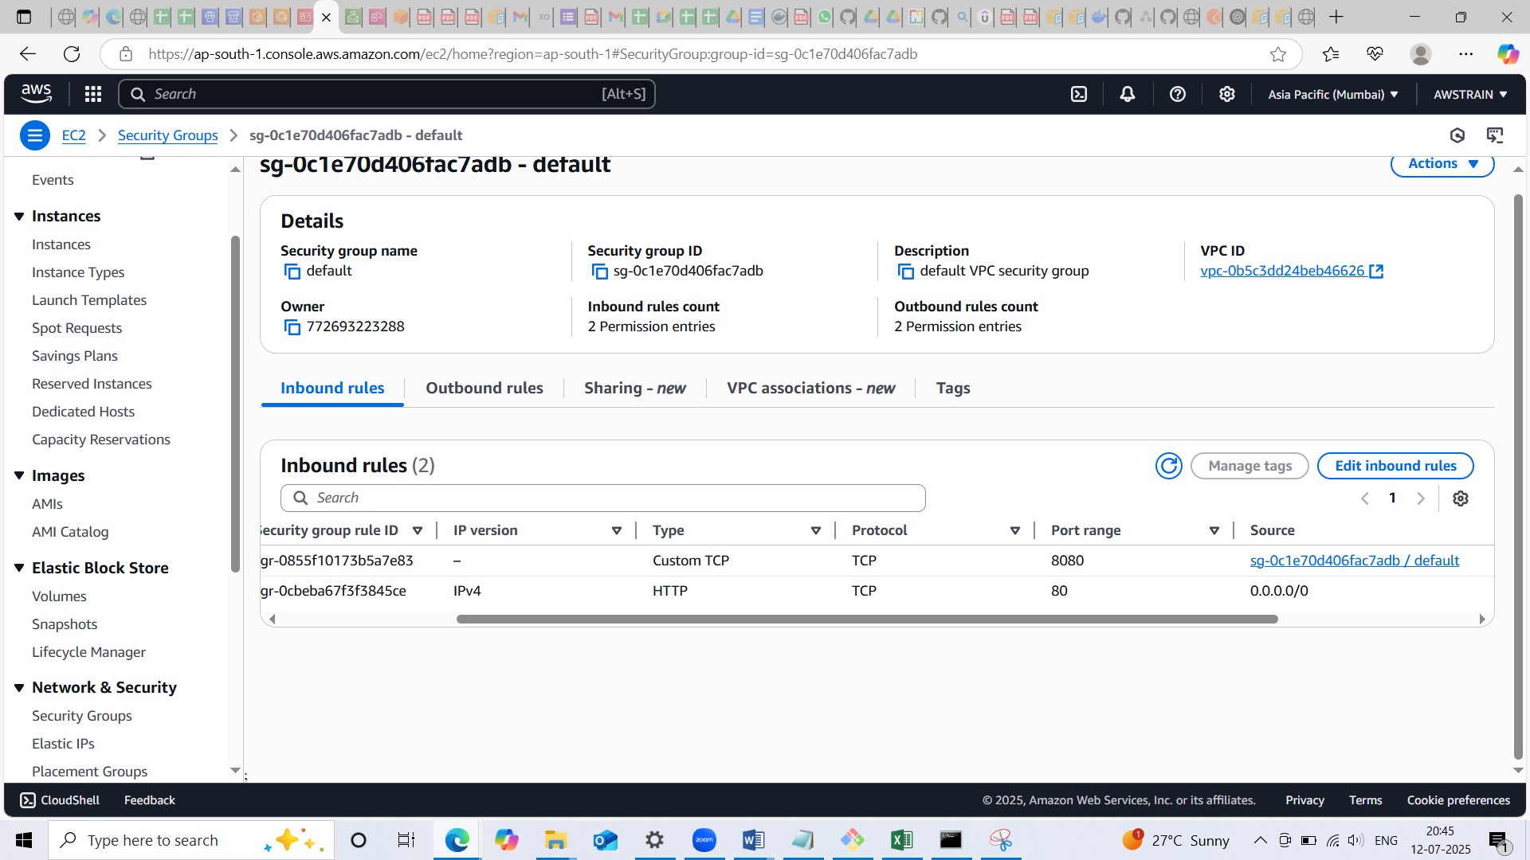

* Next created service named ‘course-service’
* Use Task definition with the latest version
* Desired task is 1
* Selected lauch type Fargate and Blue/Green deployment option
* Selected service role for codeploy named ‘codedeployecs’
* Attach the existing application load balancer and targets groups which we created earlier

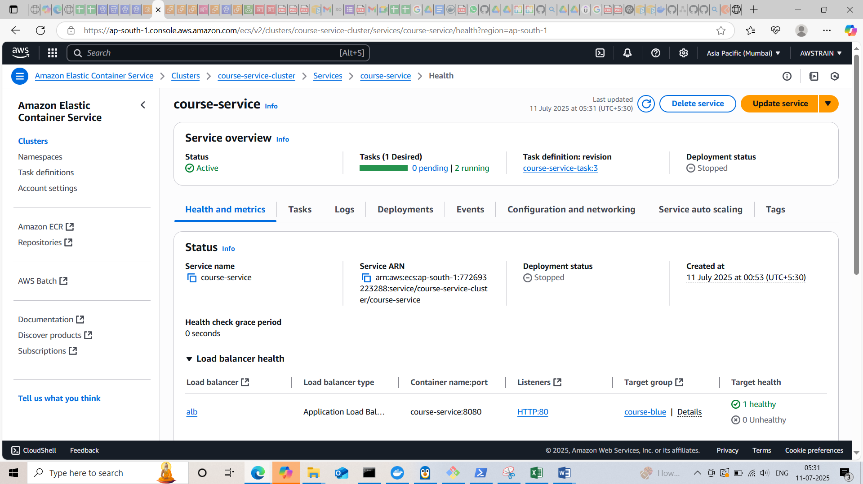

* Service role for codeploy(codedelpoyecs) have the following permissions
* [AmazonECS_FullAccess](https://us-east-1.console.aws.amazon.com/iam/home?region=ap-south-1#/policies/details/arn%3Aaws%3Aiam%3A%3Aaws%3Apolicy%2FAmazonECS_FullAccess)
* [AmazonS3FullAccess](https://us-east-1.console.aws.amazon.com/iam/home?region=ap-south-1#/policies/details/arn%3Aaws%3Aiam%3A%3Aaws%3Apolicy%2FAmazonS3FullAccess)
* [AWSCodeDeployRoleForECS](https://us-east-1.console.aws.amazon.com/iam/home?region=ap-south-1#/policies/details/arn%3Aaws%3Aiam%3A%3Aaws%3Apolicy%2FAWSCodeDeployRoleForECS)
* Ensure Service health and taget associated with the load balancer are healthy

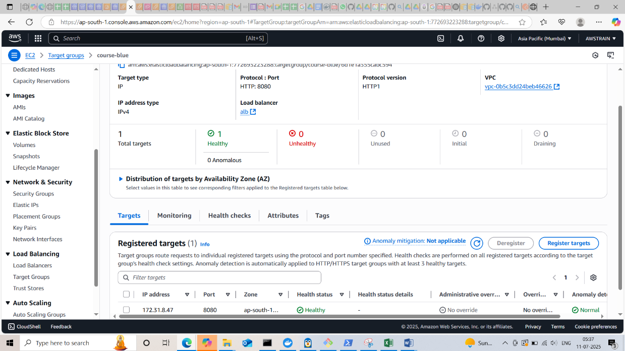

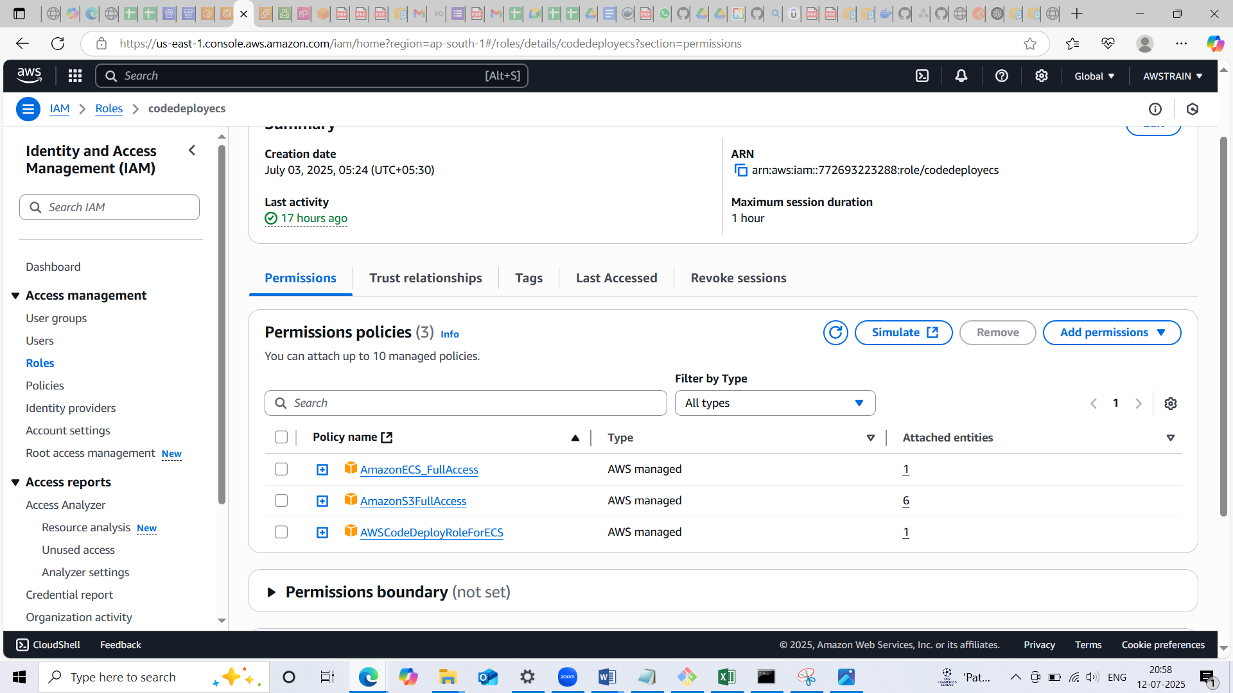

* Next step is to create an application in code deloy named ‘course app’
* Compute platform is Amazon ECS

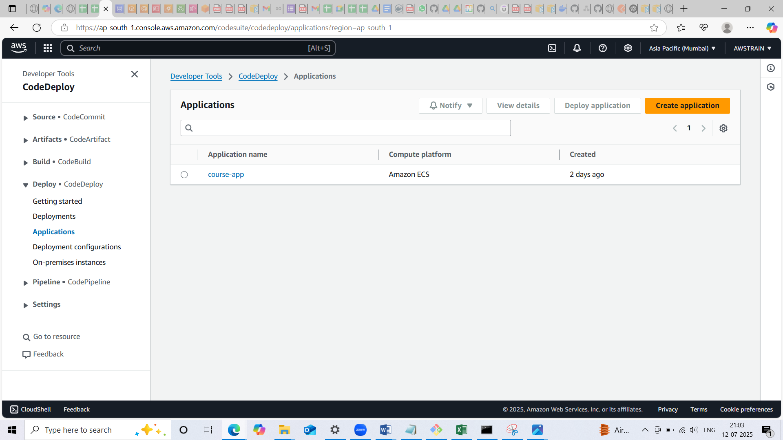

* Once created the application, next we created the deployment group named ‘course-deployment-grp’ and attach the load balancer and target groups which we created earlier

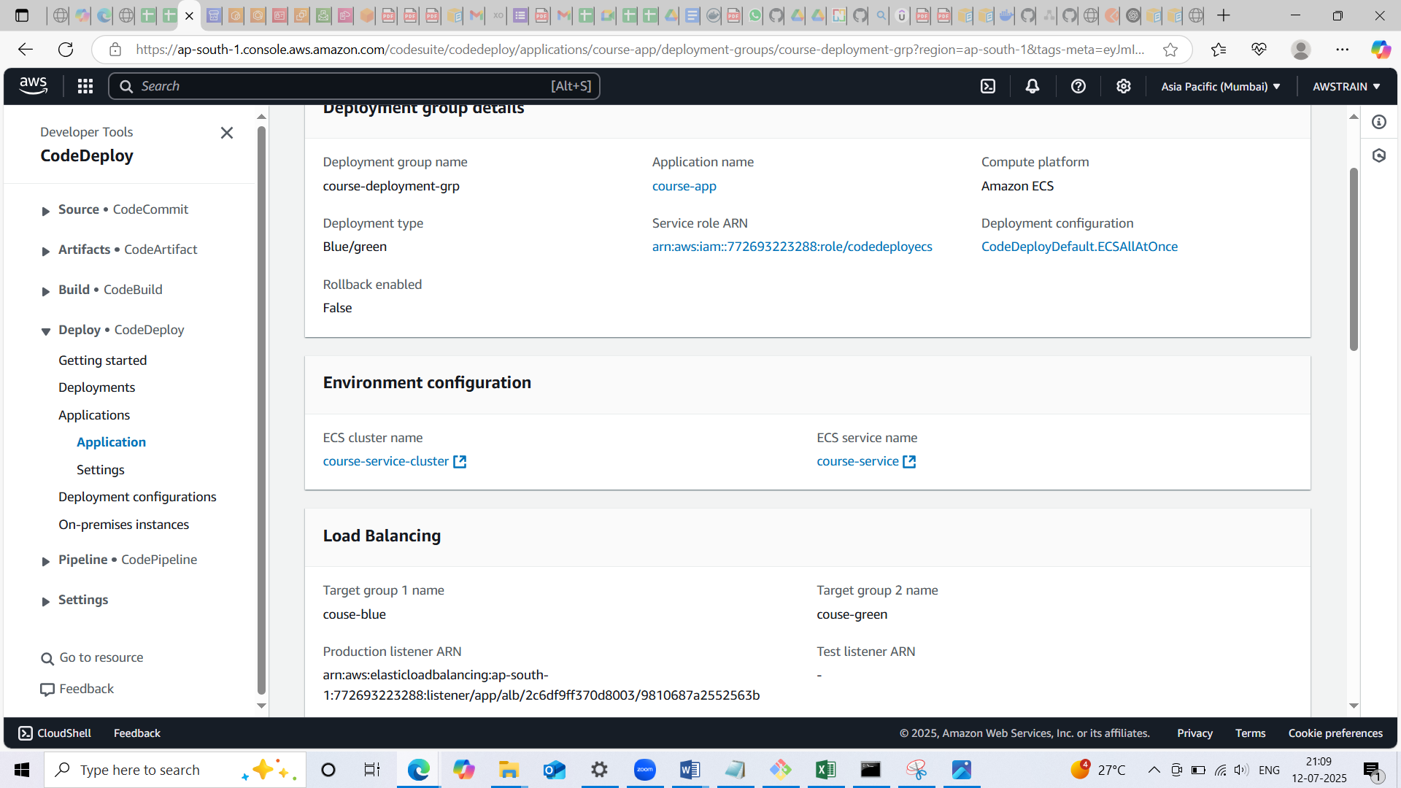

* Next we created the code pipeline named ‘course-pipeline’
* Category is custompipeline
* Execution mode is queued
* Source stage provided with the following
* Source provider is GitHub(via Github App)
* Create the github connection pointing to the corresponding repository
* Enabled the webhook for filter
* Output artifact is SourceArtifact

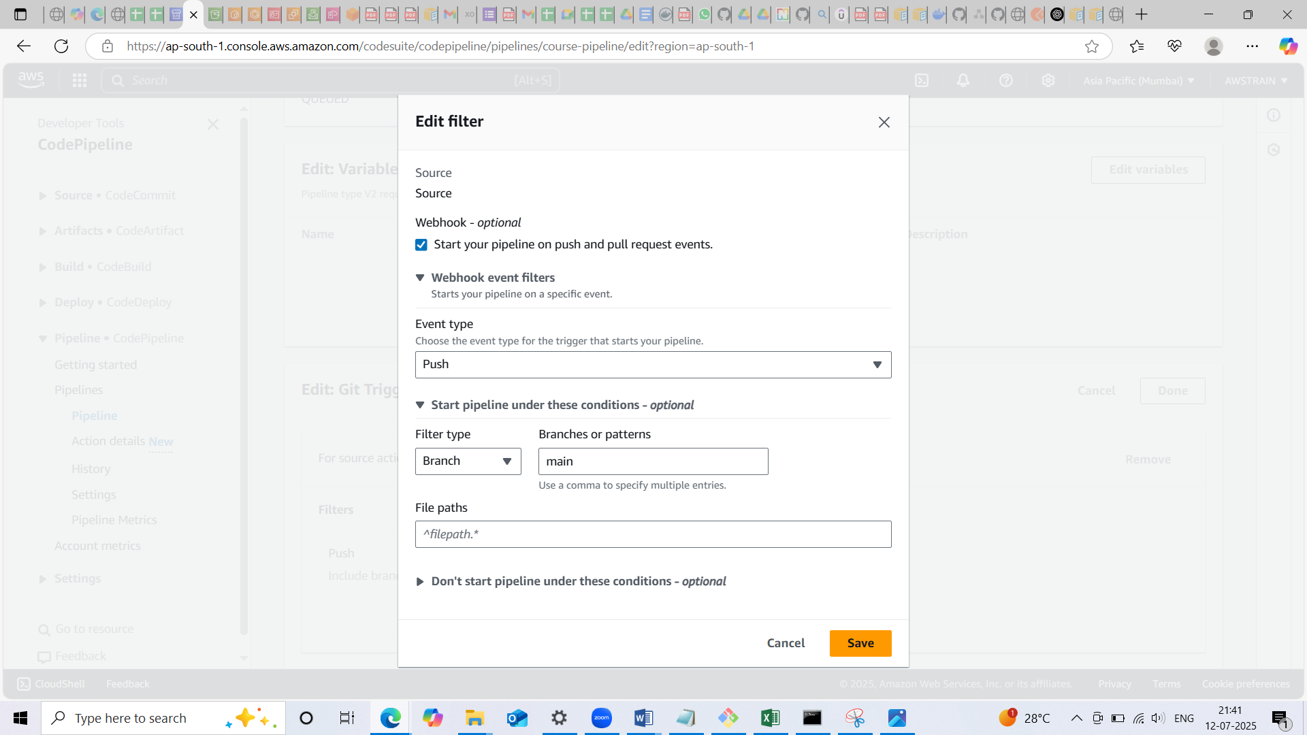

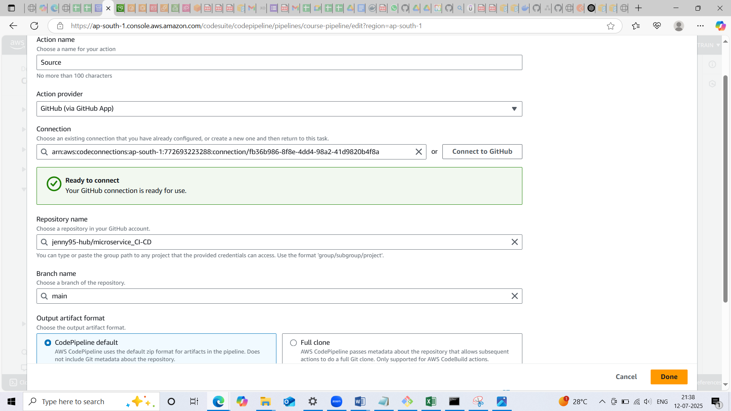

* Build stage is provided with the following:
* Build provider is AWS CodeBuild
* In the builsstage we created the project named ‘course-project’ where we mentioned the buildspec.yaml

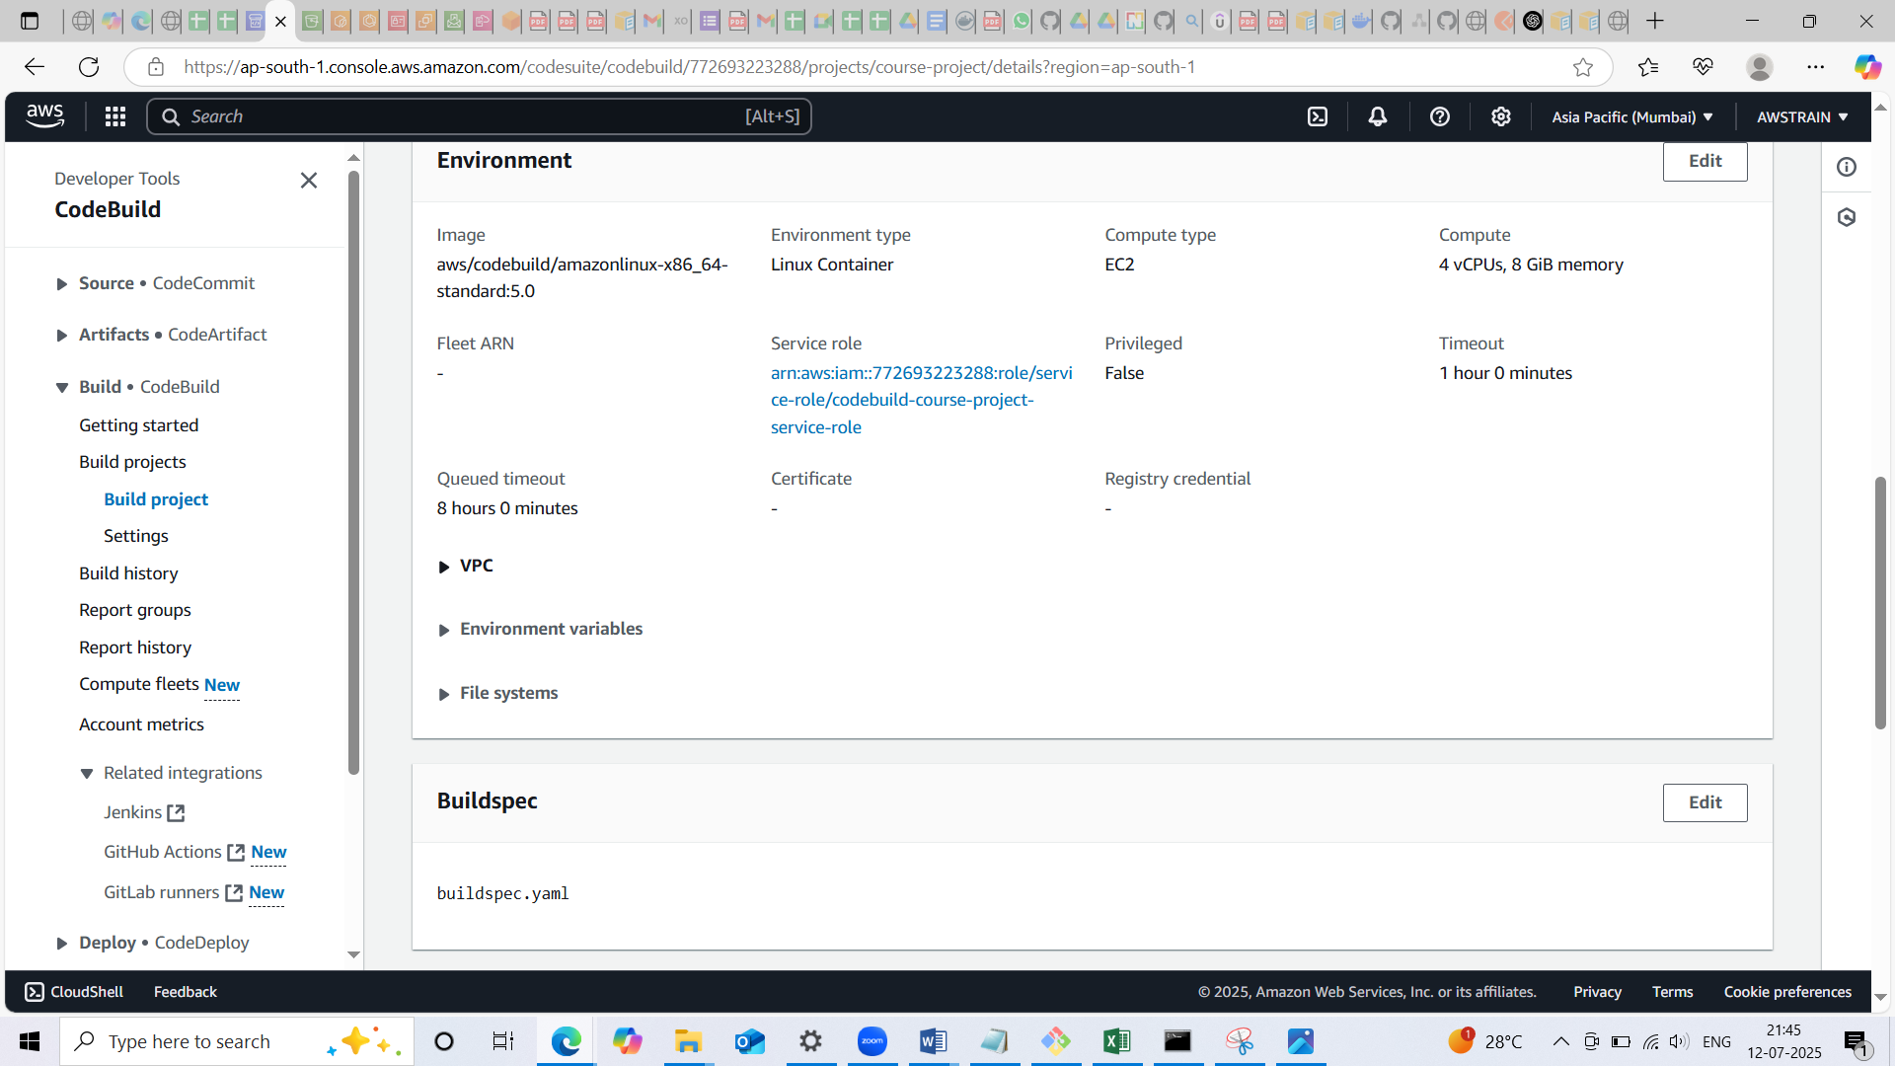

Input artefact is the SourceArtifact

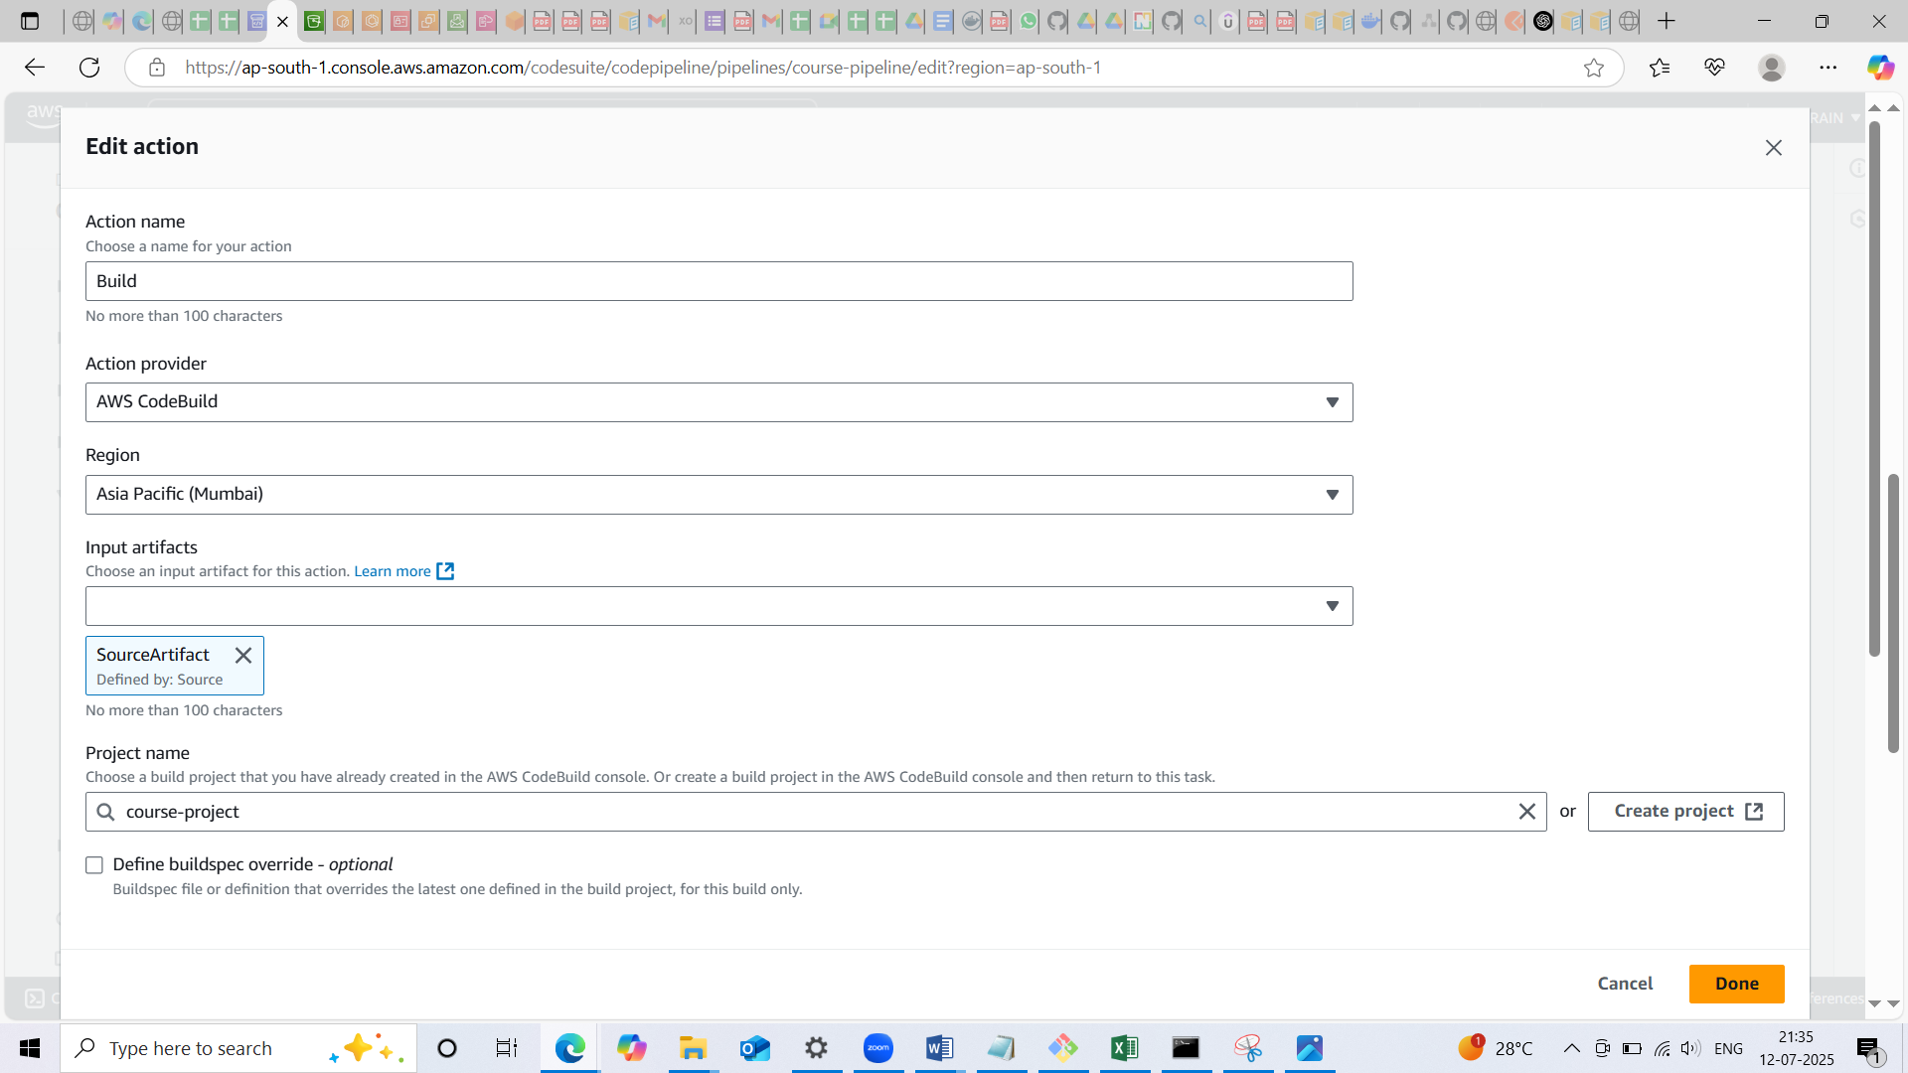

* Deploy stage is provided with the following
* Deploy provider is AWS CodeDeploy
* Input artefact is BuildArtifact
* Provide the application name and deployment group which we created earlier

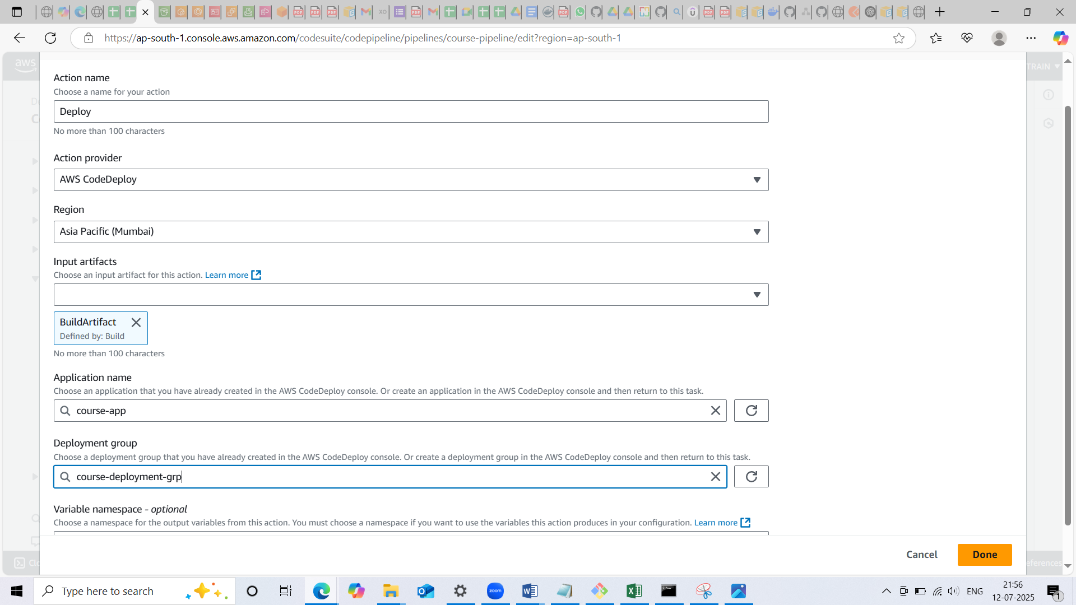

Thus finish the creation of pipeline!

* Automate Deployment to ECS takes place whenever there are changes in the repository (webhook is enabled)

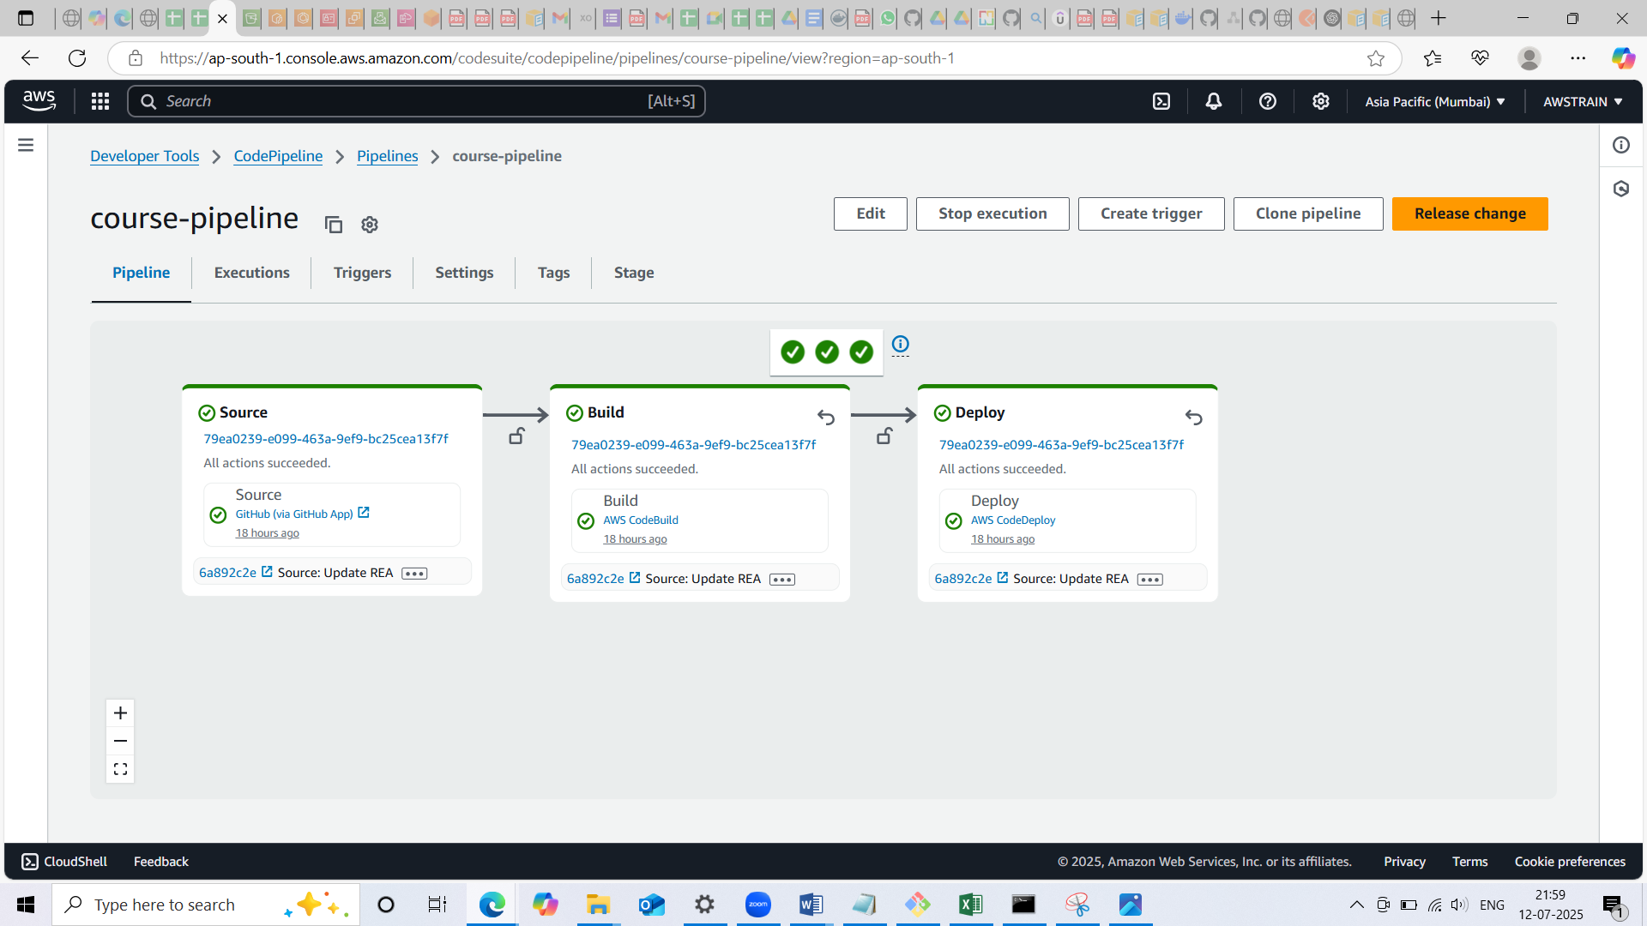

* Once the code pipeline execution is successful we can verify the ECR for the latest push and pull record

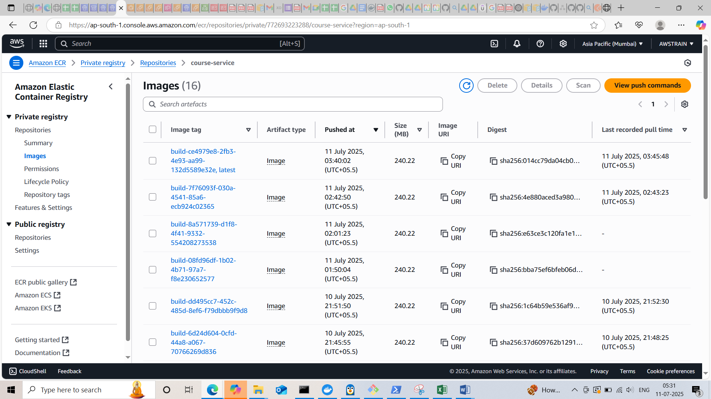

* We can check the events in service

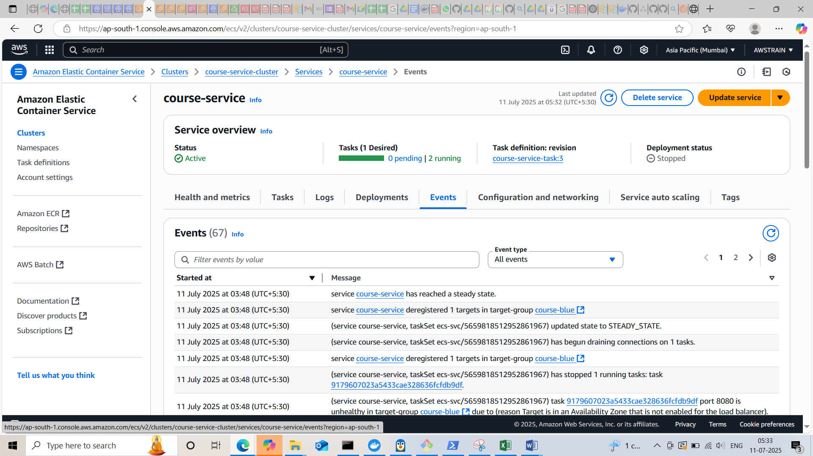

* Verify in the deployment id for the status of our deployment. For the initial release original task will be 0% and replacement task will be 100%. For the further release will get original task with 100% and original task with 0%

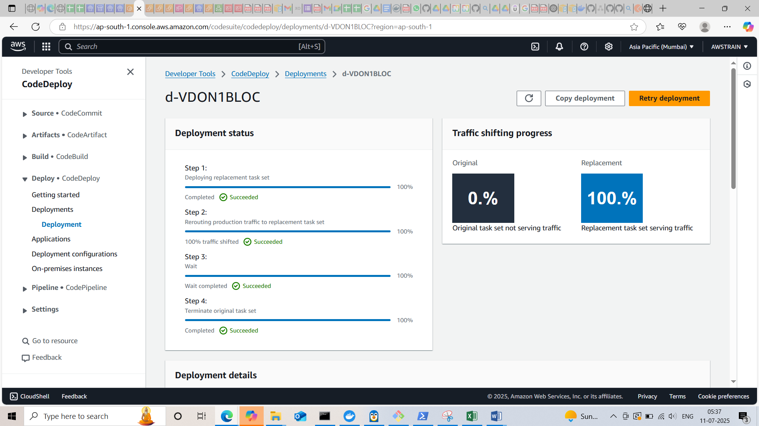

* Now we can access the microservice through the load balancer dns

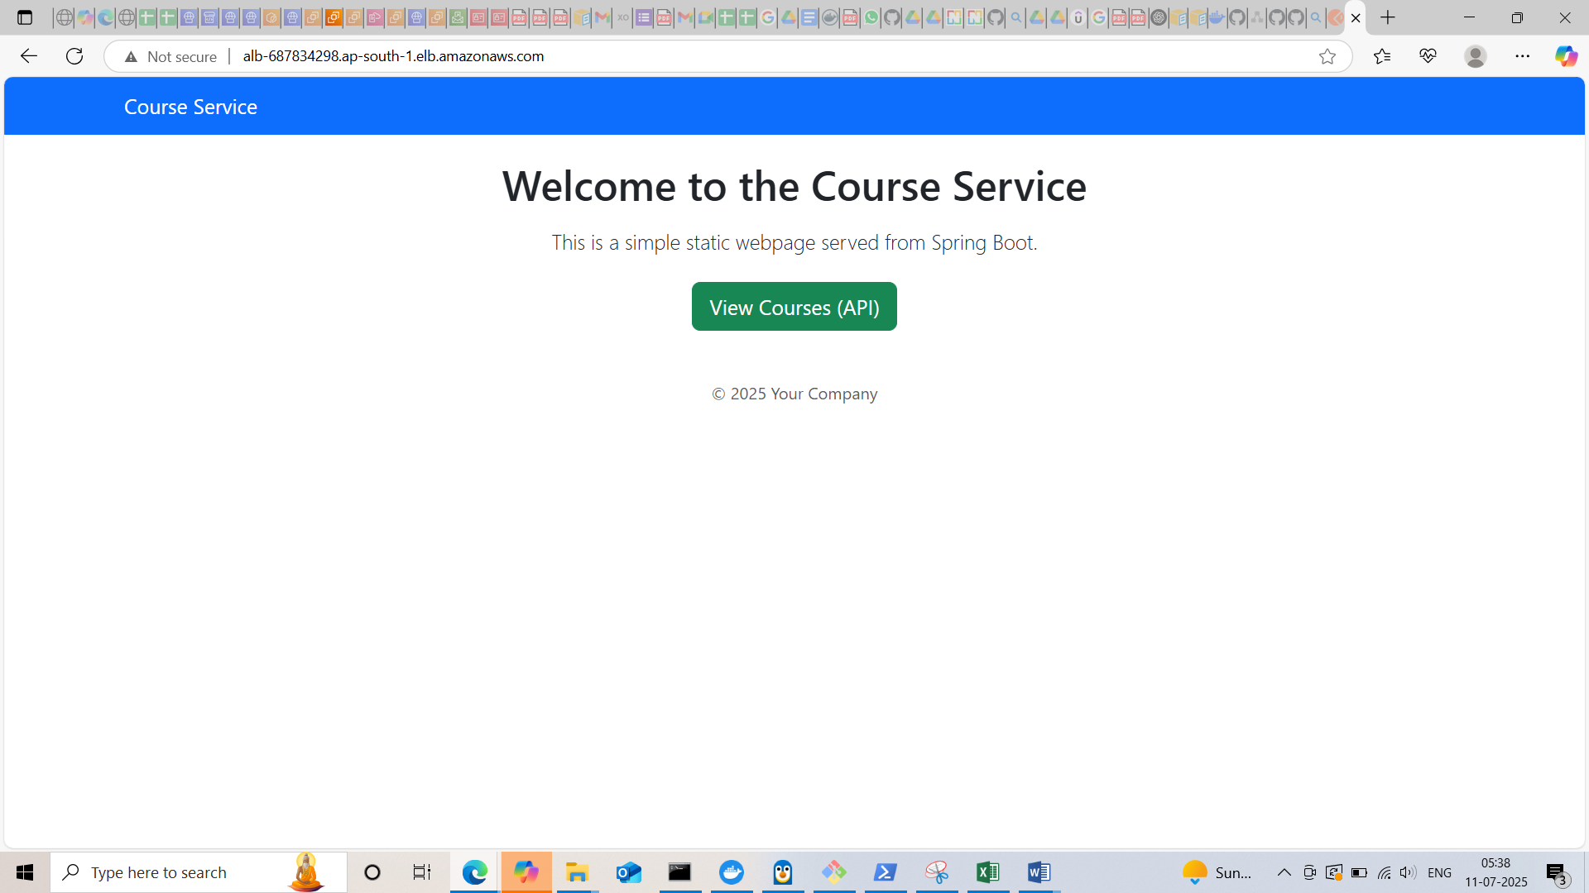

* dns with welcome page

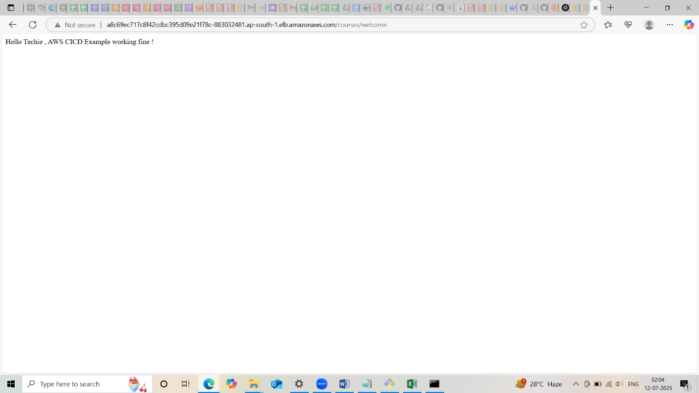

* We can check the cloud watch logs

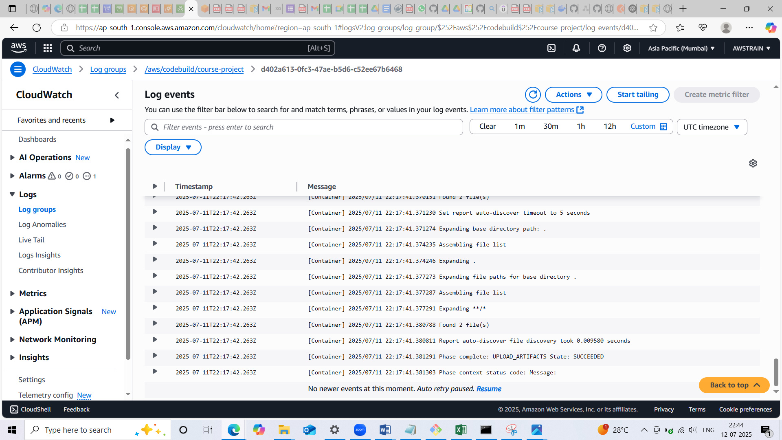

* Created cloud watch alarm for the ECS

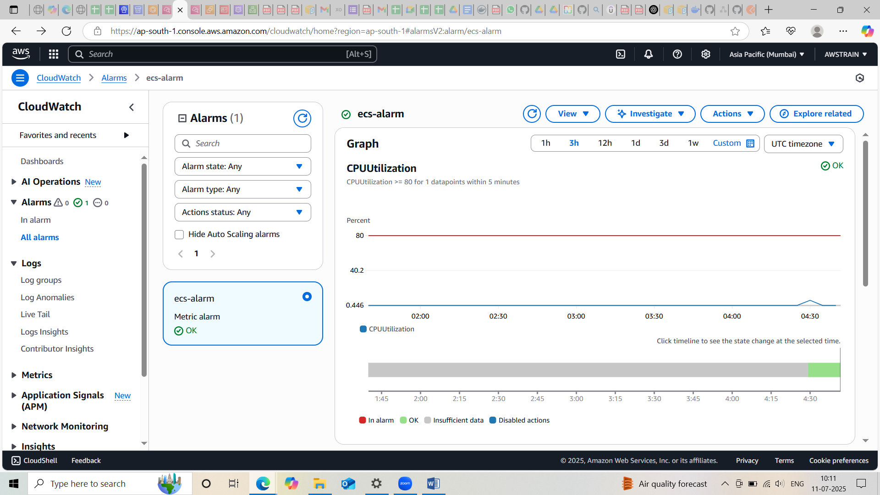

* Deployment history will be available in the Deployments of Codedeploy



**Architecture**

